

COMPUTER SCIENCE – Mobile Apps 2
Group B
Assignment 2
Eugene O'Regan

Simple App

Student: Nathalia Macedo
Student number: 77742

Contents
Section 1 3
State 3
BaaS 5
Exceptions 1 8
Exceptions 2 9
Section 2 12
Appendix A – Use of AI: Conversation with Claude 13

Section 1

State
- In a simple app, insert a button that will increment two counters.
- Ensure one of the counters is set up to survive configuration changes and the other is not.
- Ensure State Hoisting is employed.
Screenshots:
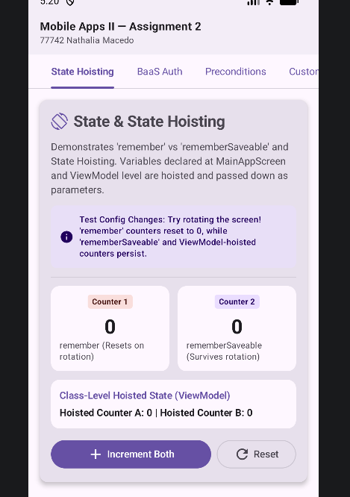
Figure 1 - Initial state: both counters at 0.
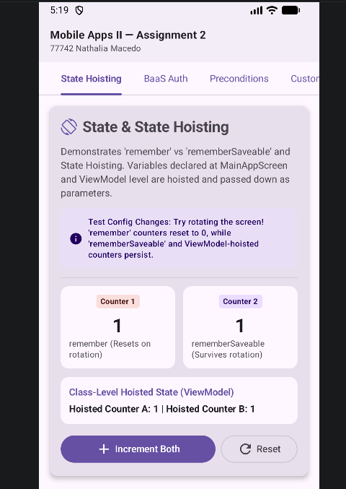
Figure 2 - After pressing “Increment Both” three times, both counters show 2.

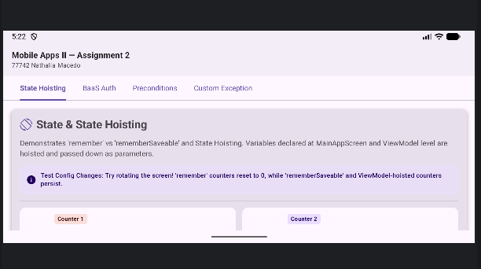
Figure 3 - fter rotating the screen, the remember counter resets to 0, while the rememberSaveable counter keeps its value.
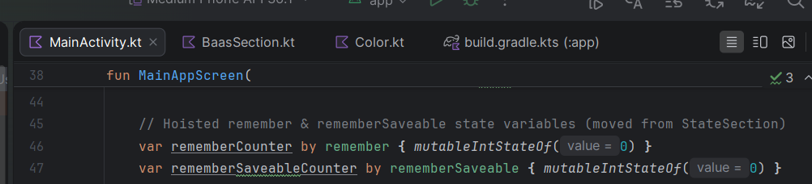
Figure 4 - Both counters declared in MainAppScreen using remember and rememberSaveable.
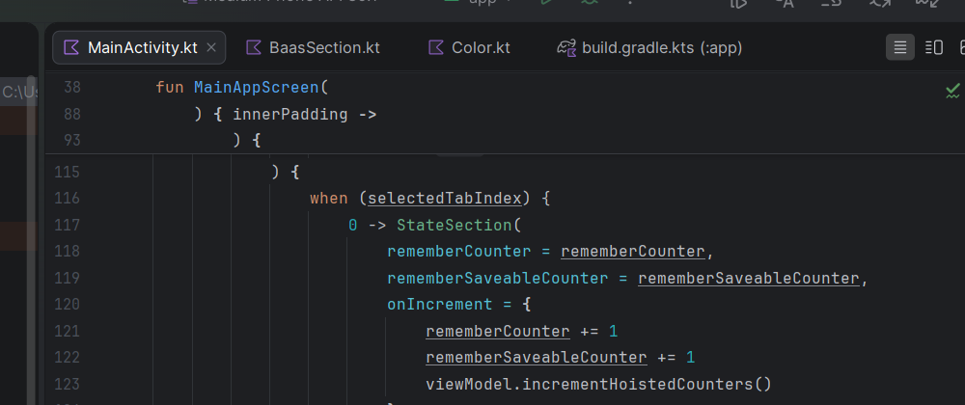
Figure 5 - The counter values and the onIncrement callback passed to StateSection as parameters.
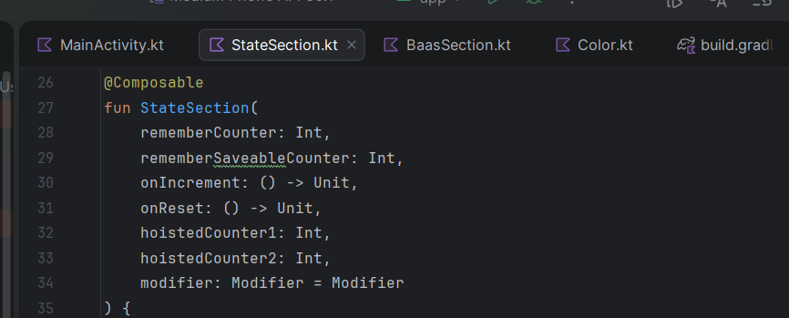
Figure 6 - StateSection receives the values and the callback as parameters and holds no state of its own.
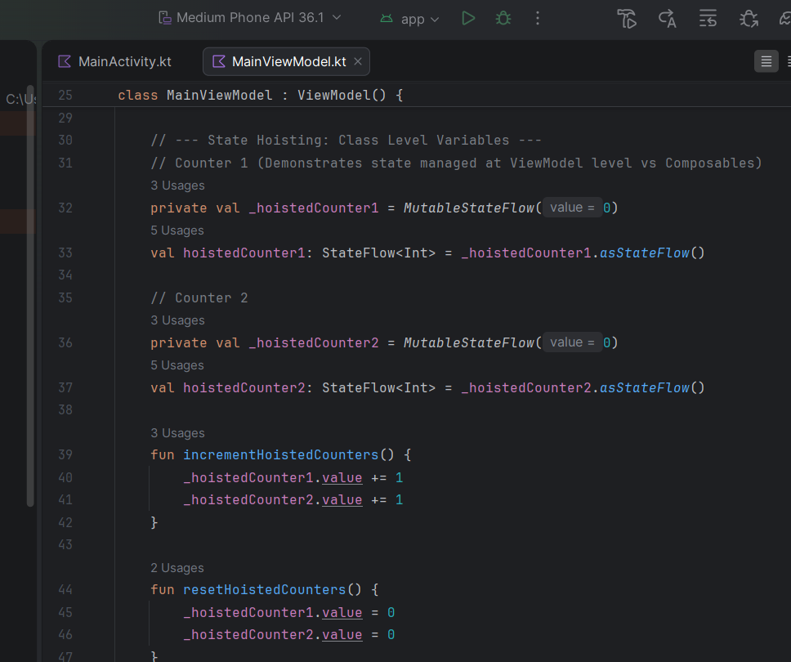

Figure 7 - Class-level state in MainViewModel, exposed as StateFlow and passed down as parameters.

BaaS
- Implement simple BaaS authorisation in the above app.
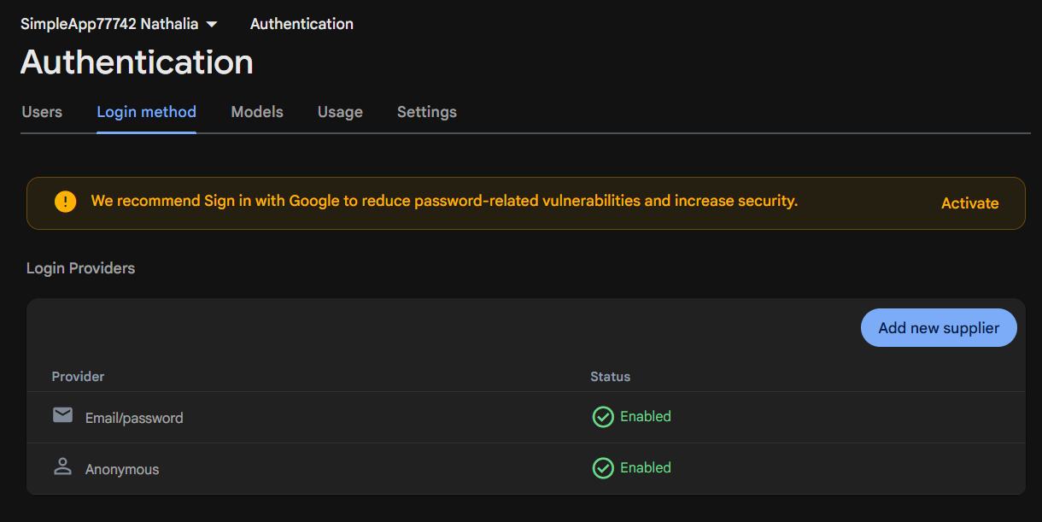
Figure 8 - The Firebase project “SimpleApp77742 Nathalia” with the Email/Password and Anonymous sign-in providers enabled in the Firebase console.

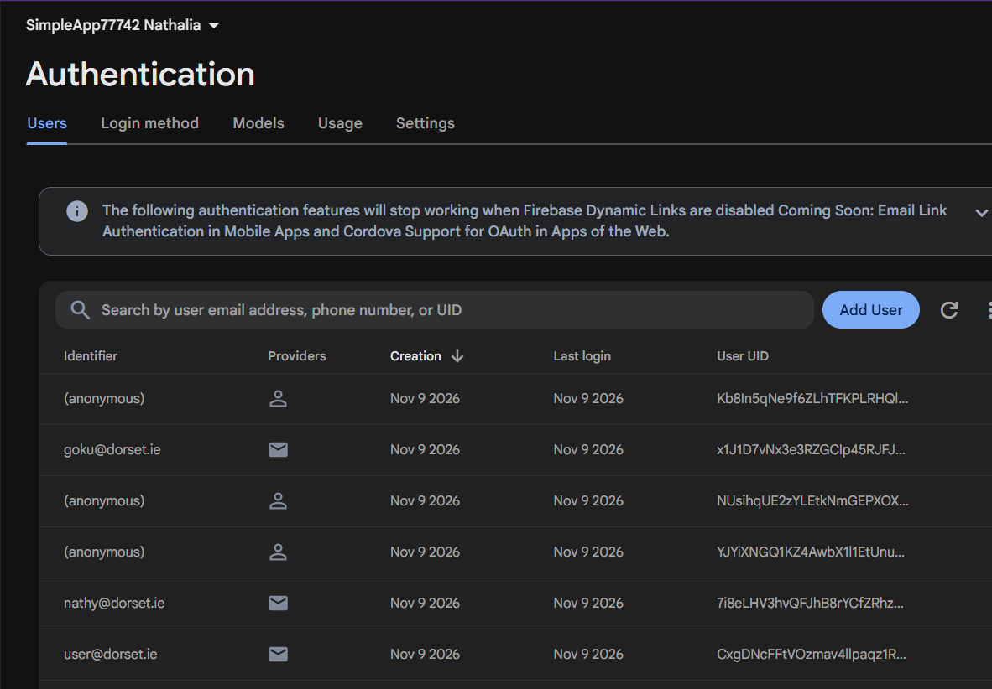
Figure 9 - Users registered through the app appear in the Firebase console with their creation date and UID, which shows the app is connected to a real backend.
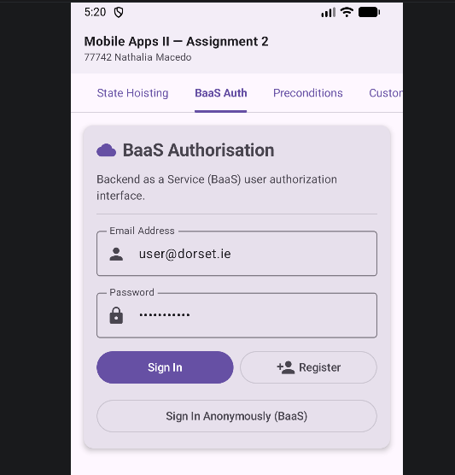
Figure 10 - The authorisation screen, with email and password fields and options to register, sign in or sign in anonymously.
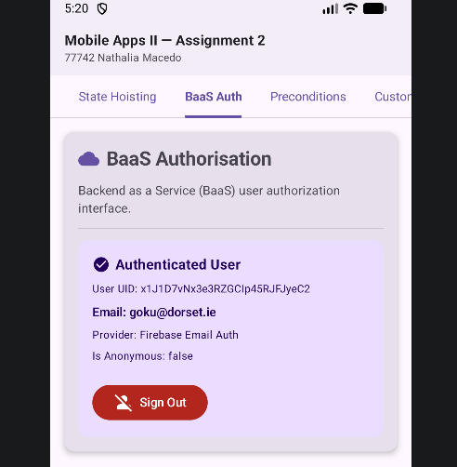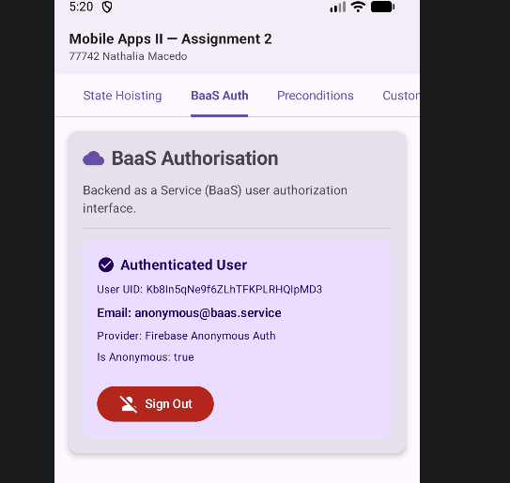
Figure 11 - After signing in, the app shows the user’s UID, email and provider, and Anonymous sign-in. The UID matches the one listed in the Firebase console (Figure 9).
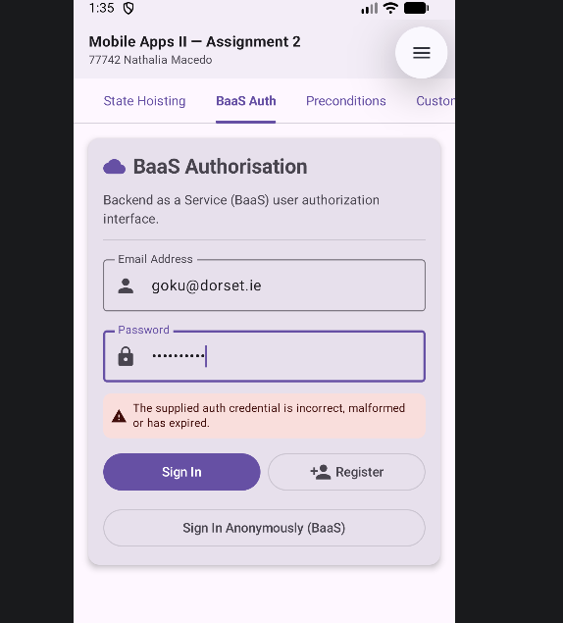
Figure 12 - When sign-in fails (for example, with a wrong password), the error returned by Firebase is caught and displayed, and the app does not crash.
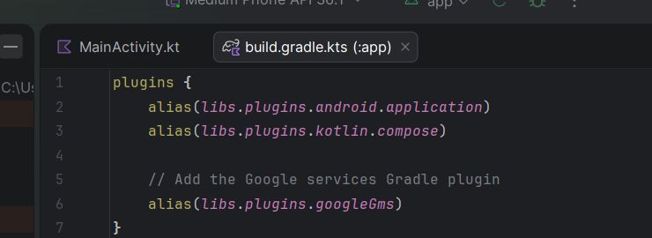
Figure 13 - The Google Services plugin and the Firebase BoM and Authentication dependencies in app/build.gradle.kts, added following the Firebase setup guide.

Use of AI – Firebase / BaaS

I had tried to complete the development of the integration of Firebase over several sessions, and I had worked step by step on the brief provided to me, and I had read the documentation of Android and Firebase, to finally use two AI tools.

- Gemini agent in Android Studio: It writes and amends Firebase code such as in BaasAuthManager.kt as well as adds or amends Firebase related lines in Gradle files based on the given error.

- Claude (claude.ai): summarized the requirements of the brief for me, step by step configured the Firebase in the console for me, assisted with debugging errors and I could have then received feedback on my completed project against the brief.

Because work was done in many small steps, for many of the steps no complete record has been kept of all relevant AI interaction(s). The rest of the evidence for this section is provided complete. As the Firebase code exceeds the Level 3 limit of 1–2 lines of code per use case, all the code is provided in full.

Exceptions 1
- Use Precondition Functions to cater for the following scenarios
  - A light is not turned on
  - A user input for a number is not negative.
- Ensure that the exceptions themselves are caught and handled appropriately

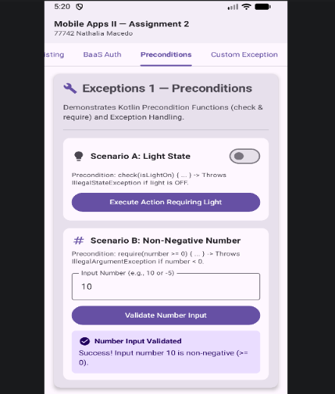
Figure 14 - With the light switched off, the action fails the check() precondition. The IllegalStateException is caught and its message is displayed, so the app does not crash. A value of zero or above meets the require() condition and is accepted.
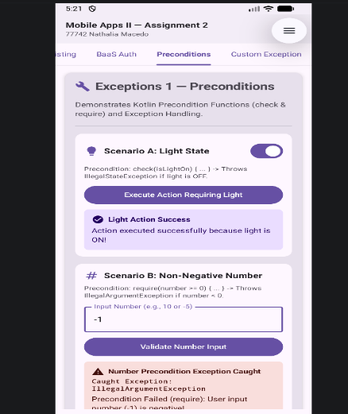
Figure 15 - With the light switched on, the check() condition is met and the action completes successfully. A negative number fails the require() precondition. The IllegalArgumentException is caught and the user sees a clear message instead of a crash.
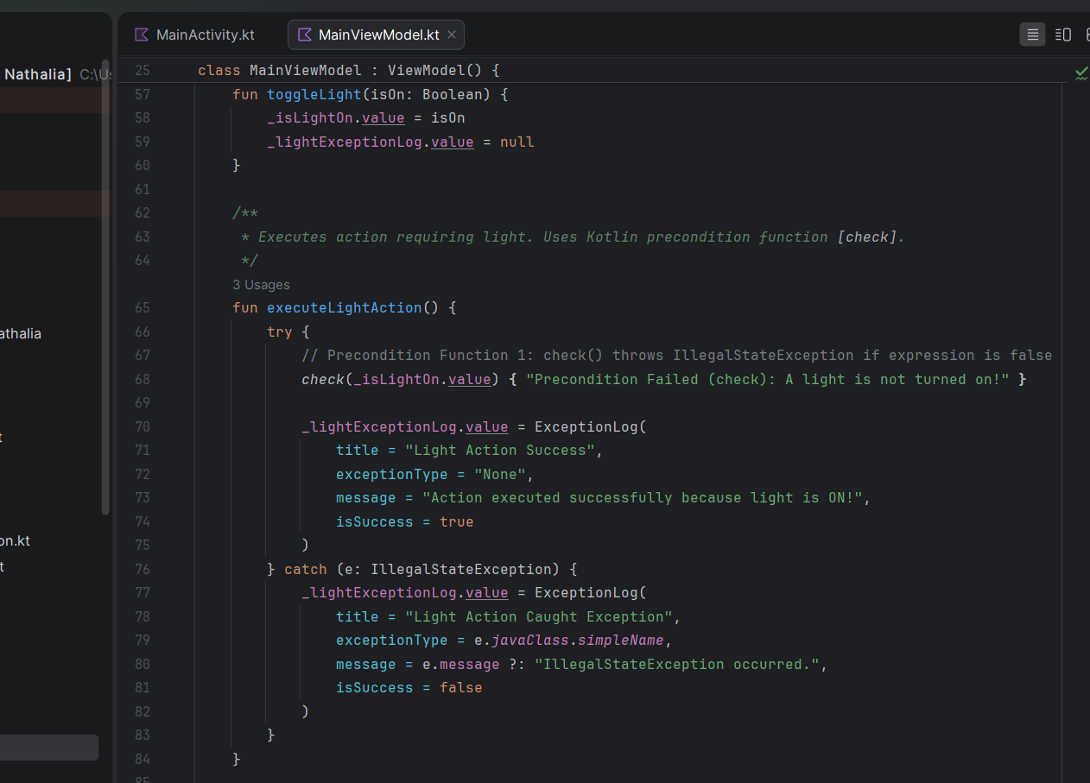
Figure 16 - check() is used because the light is part of the object’s state. If the condition is false, it throws an IllegalStateException, which is caught and turned into a message for the UI.
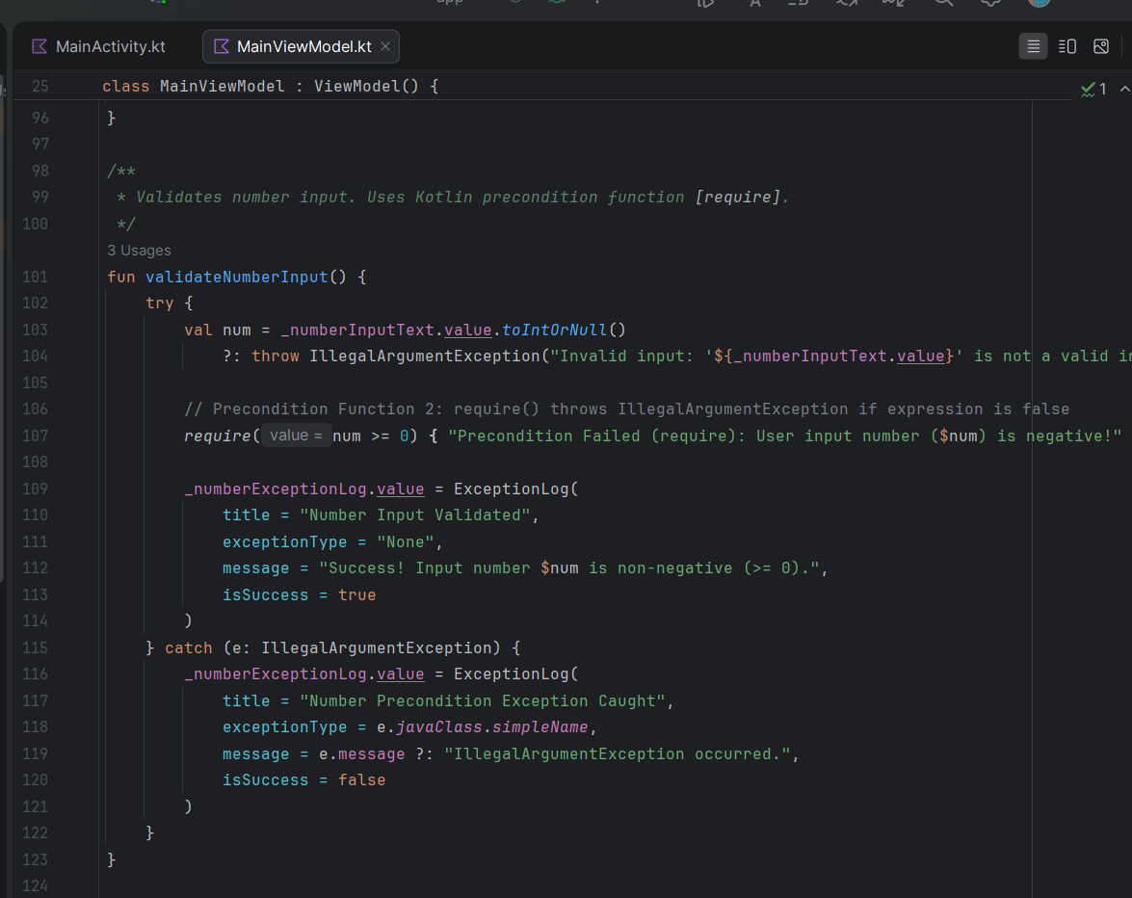
Figure 17 - require() is used because the number is an input argument. If it is negative, it throws an IllegalArgumentException, which is caught and shown to the user.

Exceptions 2

- Create a custom exception that will be provoked if the length of a word being checked is greater than 10 characters.
- Ensure that the Exception itself can be extended
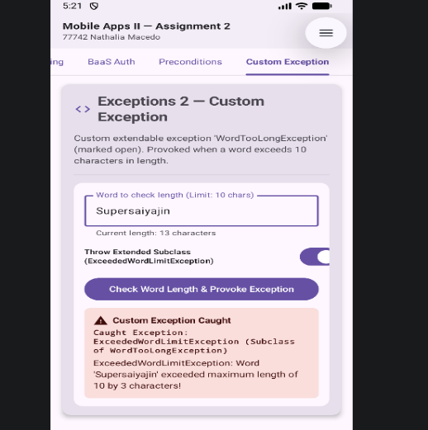
Figure 18 - With the subclass option on, ExceededWordLimitException is thrown instead. It adds the number of extra characters, and it is caught by the same catch (e: WordTooLongException) block, because a subclass is also a WordTooLongException.
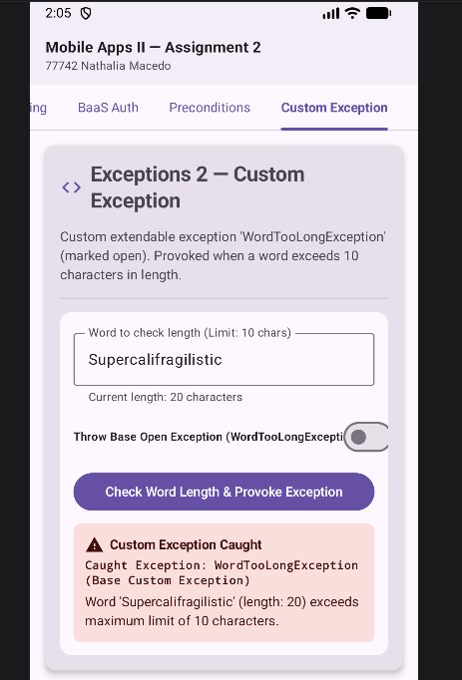
Figure 19 - When the word has more than 10 characters, the custom WordTooLongException is thrown, caught and displayed with the word and its length.
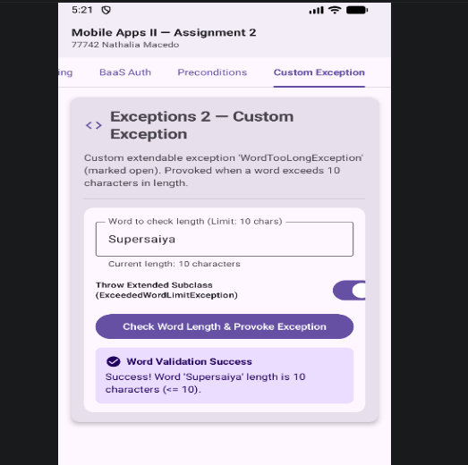
Figure 20 - Words of up to 10 characters are accepted and no exception is thrown.

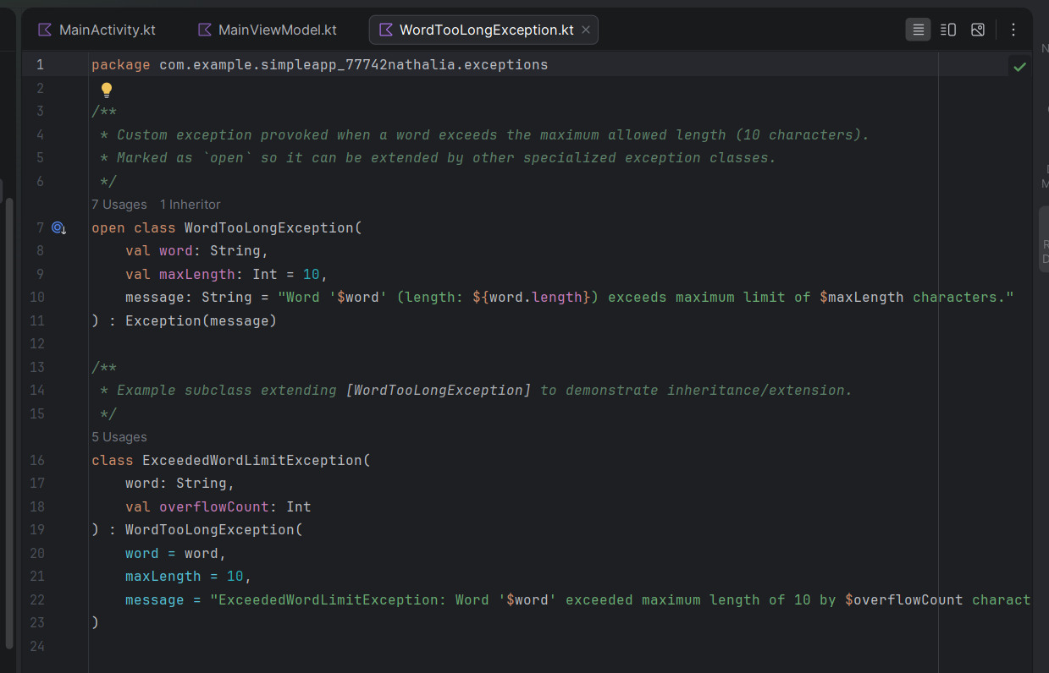
Figure 21 - Kotlin classes are final by default, so WordTooLongException is marked open to allow it to be extended. ExceededWordLimitException inherits from it and adds an overflowCount property, which shows the exception can be extended.

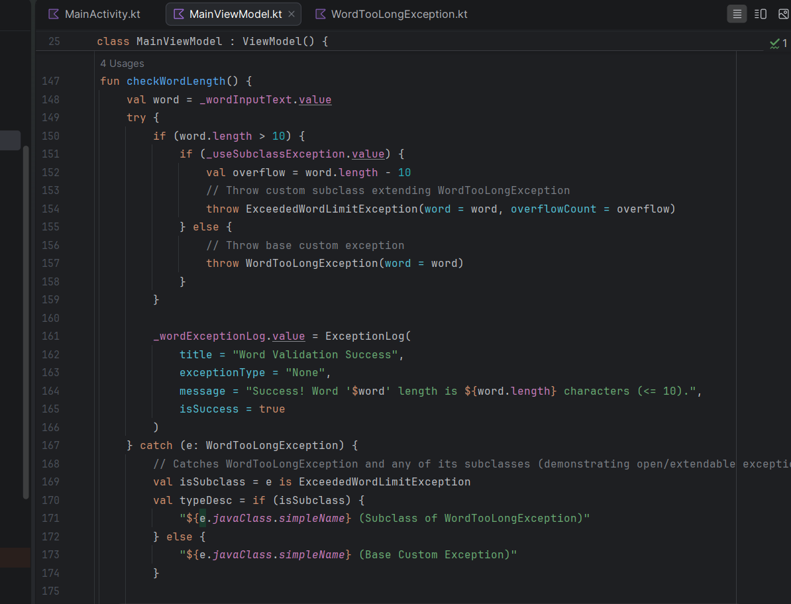
Figure 22 - checkWordLength() throws the base exception or its subclass when the word is longer than 10 characters. A single catch (e: WordTooLongException) handles both, which demonstrates polymorphism in exception handling.

Section 2

- What are the key differences between Kotlin implementation of Exceptions to that of Java?
The main difference between exceptions in Kotlin and Java is how the compiler expects developers to handle them.
Java (checked exceptions: IOException must be caught in a try/catch block or declared with throws; unchecked exceptions: RuntimeException does not have to be caught or declared). All exceptions in Kotlin are unchecked, i.e. the compiler does not require to catch or declare them.
Another difference is that in Kotlin try/catch is an expression, i.e. it can return value in it:
val n = try { readNumber() } catch (e: Exception) { 0 }

In Java, try is a statement, so the variable is usually declared and assigned separately. Kotlin also allows throw inside an expression, for example: val x = input?: throw IllegalArgumentException().
Kotlin’s standard library includes require, check and error to signal invalid arguments, incorrect states or other errors. For Java interoperability, @Throws can declare exceptions on a Kotlin function for Java callers.

- How does this affect their usage by the developer?
As checked exceptions are not available in Kotlin, their absence must be compensated by other means. Such code requires less boilerplate code, is more readable. However, one must decide which errors to throw, how to document a function and test it for error cases. Without a compiler warning, an unhandled exception will lead to a failure at runtime. Errors can also be represented as values, e.g. as Result or by using runCatching.

I used to require and check to make validation more explicit and try/catch blocks where necessary to handle exceptions.

Reference
Android Developers (n.d.) State and Jetpack Compose. Available at: https://developer.android.com/develop/ui/compose/state (Accessed: 9 November 2026).
Android Developers (n.d.) Where to hoist state. Available at: https://developer.android.com/develop/ui/compose/state-hoisting (Accessed: 9 November 2026).
Firebase (n.d.) Add Firebase to your Android project. Available at: https://firebase.google.com/docs/android/setup (Accessed: 9 November 2026).
Firebase (n.d.) Authenticate with Firebase anonymously on Android. Available at: https://firebase.google.com/docs/auth/android/anonymous-auth (Accessed: 9 November 2026).
Firebase (n.d.) Authenticate with Firebase using password-based accounts on Android. Available at: https://firebase.google.com/docs/auth/android/password-auth (Accessed: 9 November 2026).
JetBrains (n.d.) Exceptions. Kotlin documentation. Available at: https://kotlinlang.org/docs/exceptions.html (Accessed: 10 November 2026).
Oracle (n.d.) Lesson: Exceptions. The Java Tutorials. Available at: https://docs.oracle.com/javase/tutorial/essential/exceptions/ (Accessed: 10 November 2026).

Appendix A – Use of AI: Conversation with Claude

The conversation with Claude (claude.ai) took place on 9 November 2026 and was held in Portuguese, my first language. The screenshots below are the original conversation. A short English description is given under each one.

I used Claude to understand the brief, to get step-by-step guidance on setting up Firebase Authentication, to troubleshoot errors and to review my project against the requirements. Claude did not write code for the app. The Firebase code in BaasAuthManager.kt was generated by the Gemini agent in Android Studio and is declared separately.
Note: the headings, figure descriptions and translated notes in this appendix were translated from Portuguese into English with Claude's help.

1. Explanation of the assignment brief
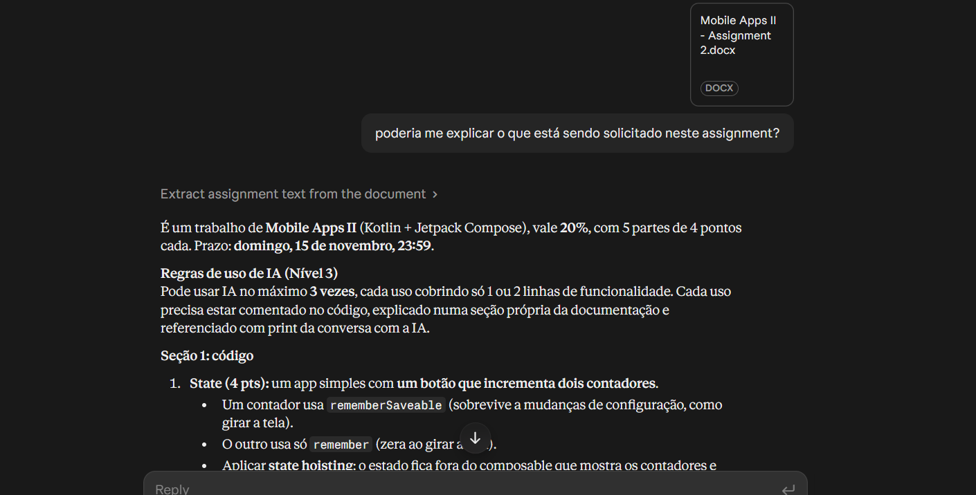
Figure 1 – I asked Claude to explain the assignment brief. Claude summarised the requirements of each part and the Level 3 rules on using AI.

My note: The conversation with Claude was held in Portuguese, my first language. A short English description is given under each screenshot.

2. Claude declined to write the code
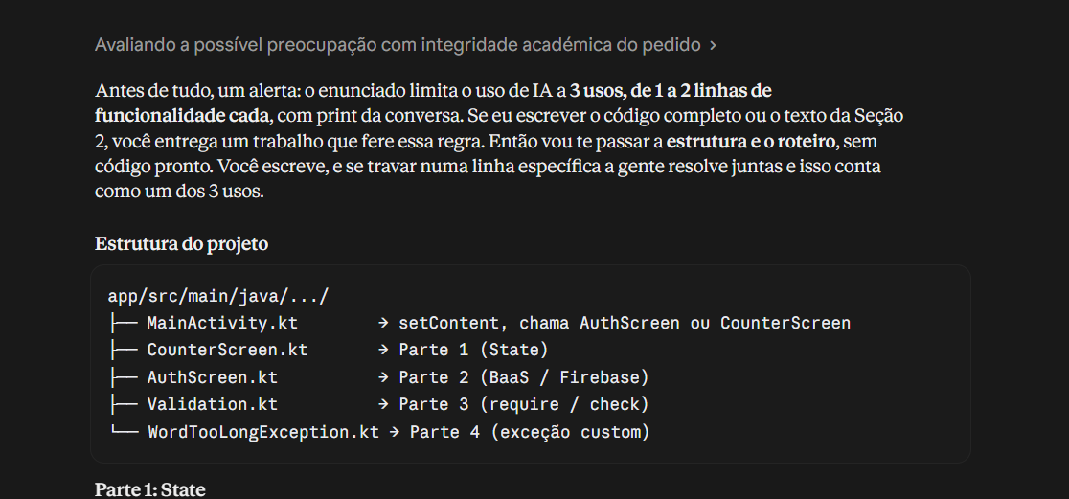
Figure 2 – Claude warned that writing the full code would break the Level 3 AI limit, so it gave me only the project structure and a plan for each part.

My note: my difficulty was with Part 2 (BaaS / Firebase).

3. First review of the project
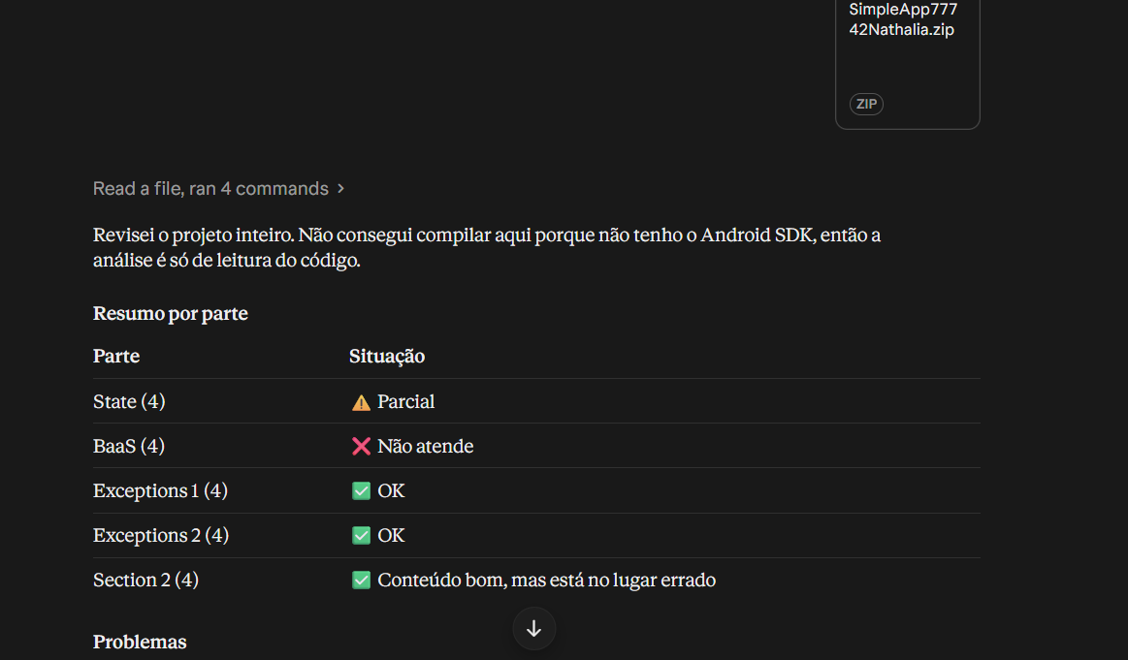
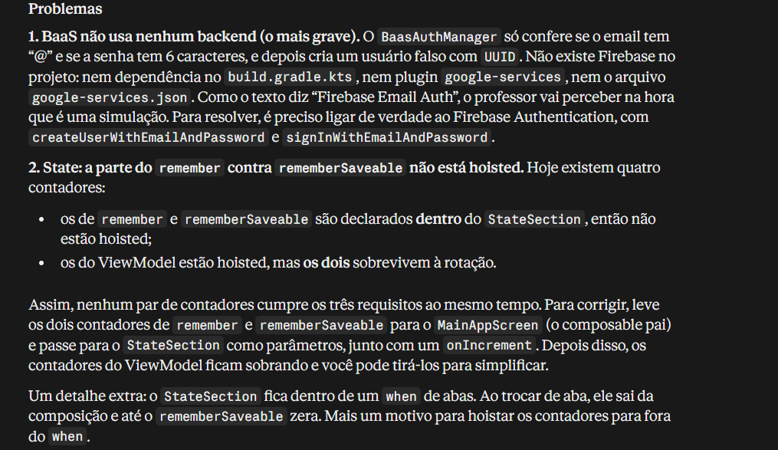
Figures 3–4 – Claude's first review of my project against the brief. The BaaS part did not use a real backend, and state hoisting was only partly correct.

My note: when Claude reviewed the project, I saw that I had not managed to implement BaasAuthManager. I then asked the Gemini agent in Android Studio for help, together with Claude.

4. Guidance on setting up Firebase
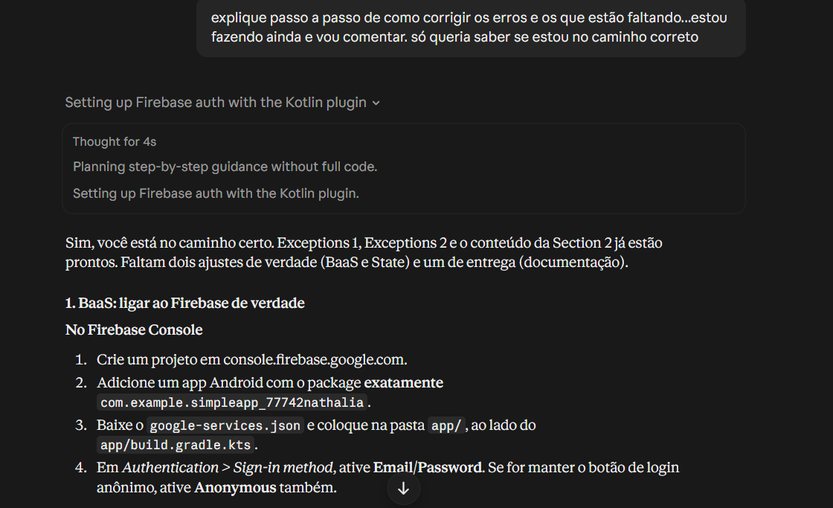
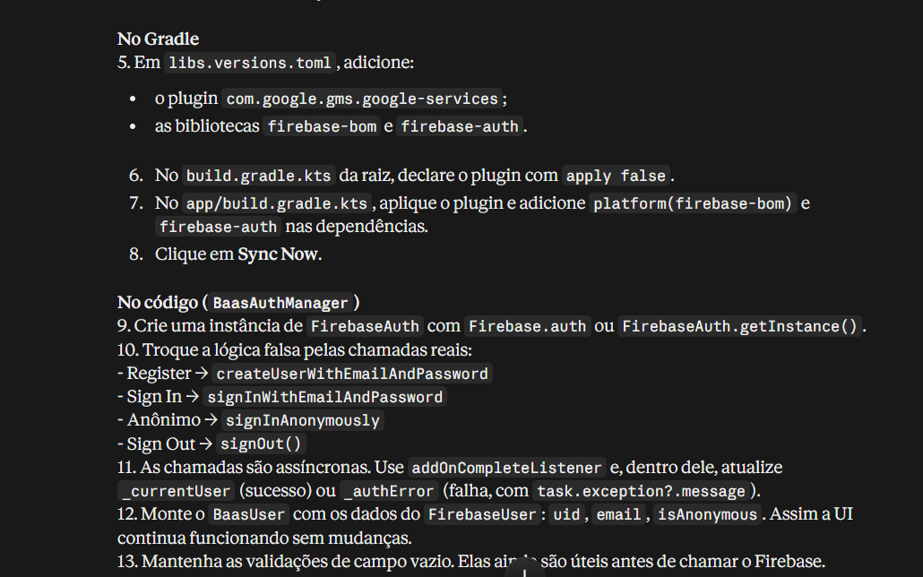
Figures 5–6 – Claude's step-by-step guidance on connecting the app to Firebase: creating the project in the console, configuring Gradle and which Firebase Authentication methods to use. No code was provided.

5. CONFIGURATION_NOT_FOUND error
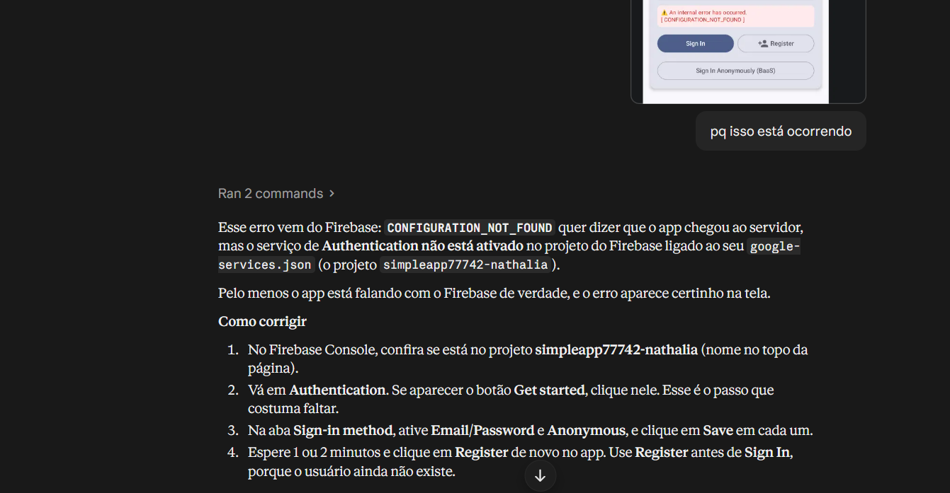
Figure 7 – My app showed the error CONFIGURATION_NOT_FOUND. Claude explained that Authentication had not been enabled in the Firebase console and how to enable the sign-in providers.
6. Final review
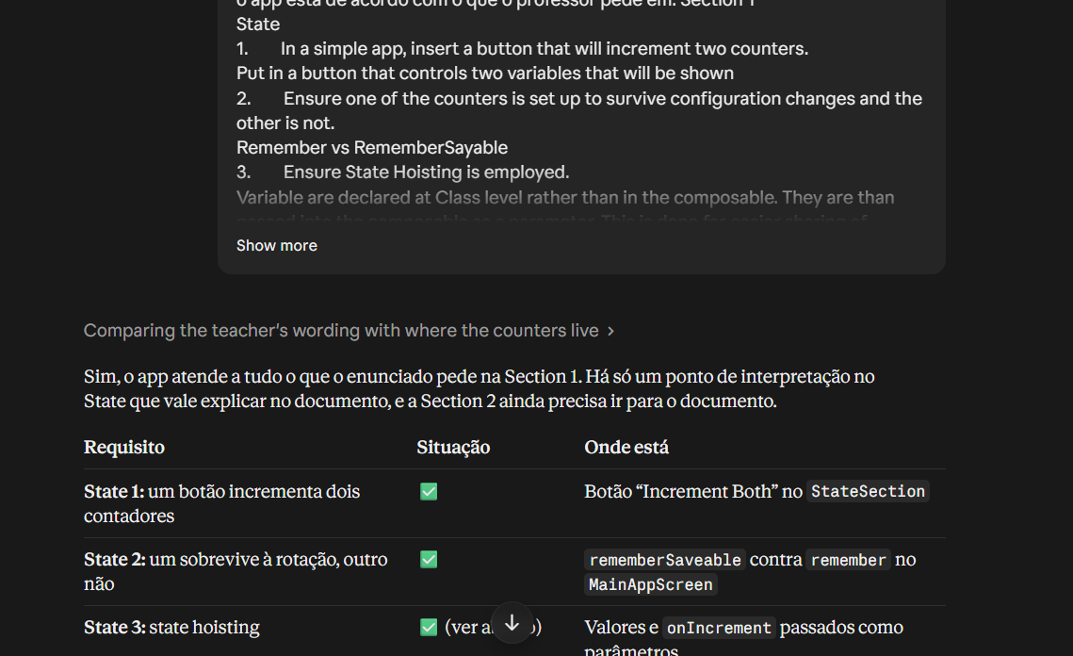
Figure 8 – Claude checked the app against each requirement of Section 1.

My note: this was the final review I requested to confirm that everything met the brief.

